DB BROWSER EXERCISES
SAMPLE DATABASE: CHINOOK.DB

✔️ Provide a query showing Customers (just their full names, customer ID and country) who are not in the US.
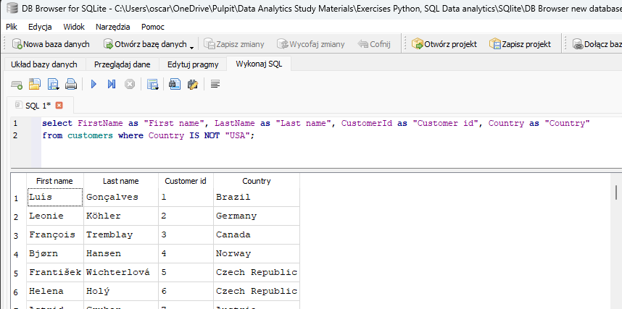
- ✔️ Provide a query only showing the Customers from Brazil.

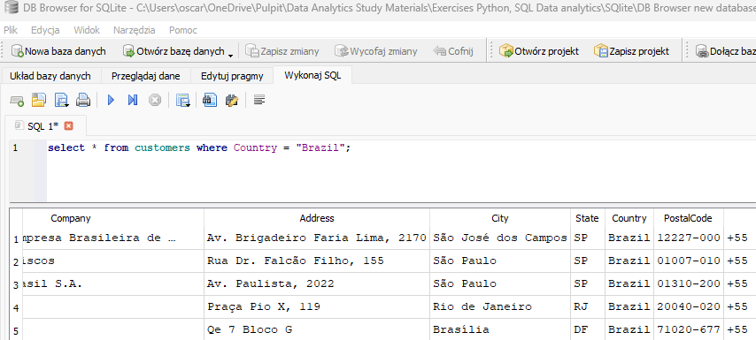
- ✔️ Provide a query showing the Invoices of customers who are from Brazil. The resultant table should show the customer's full name, Invoice ID, Date of the invoice and billing country.

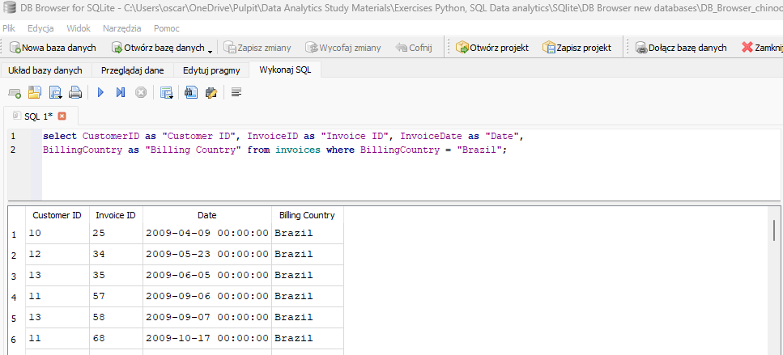

- ✔️ Provide a query showing only the Employees who are Sales Agents.

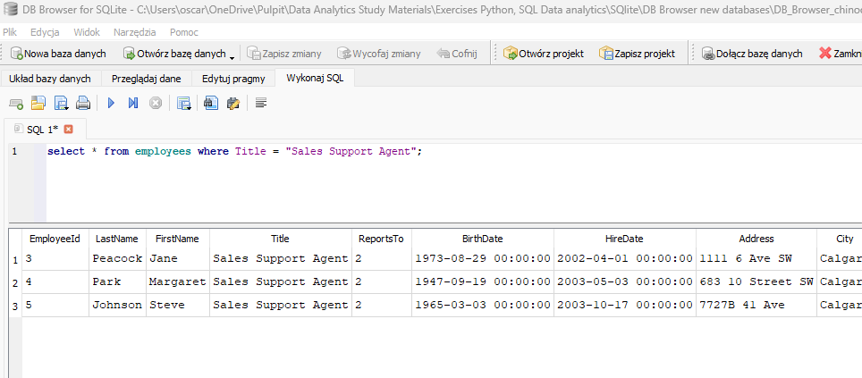
- ✔️ Provide a query showing a unique list of billing countries from the Invoice table.

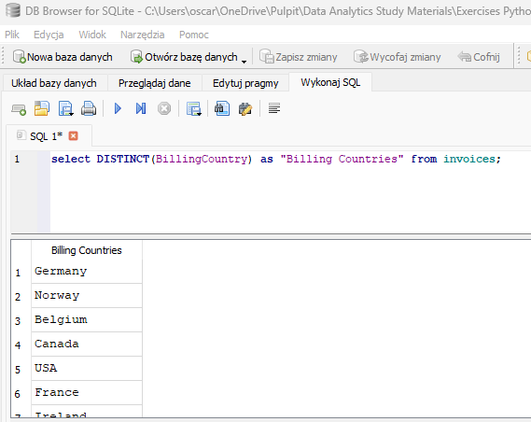
- ✔️ Provide a query that shows the invoices associated with each sales agent. The resultant table should include the Sales Agent's full name.

- ✔️ Provide a query that shows the Invoice Total, Customer name, Country and Sale Agent name for all invoices and customers.

- ✔️ How many Invoices were there in 2009 and 2011? What are the respective total sales for each of those years?
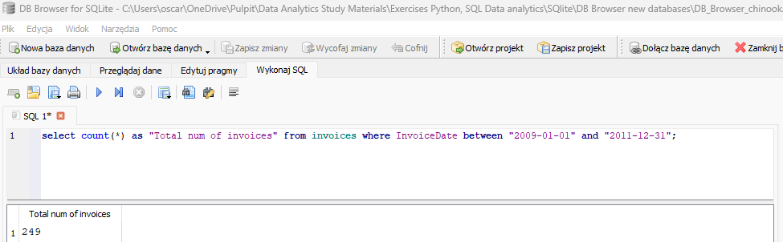
- ✔️ Looking at the InvoiceLine table, provide a query that COUNTs the number of line items for Invoice ID 37.
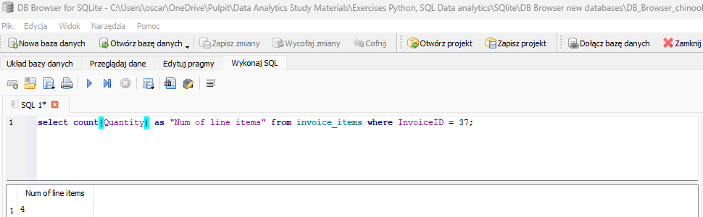
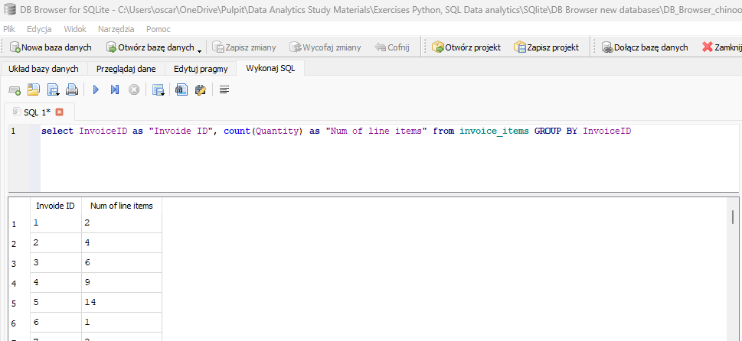
- ✔️ Looking at the InvoiceLine table, provide a query that COUNTs the number of line items for each Invoice. HINT: GROUP BY

- ✔️ Provide a query that includes the track name with each invoice line item.

- ✔️ Provide a query that includes the purchased track name AND artist name with each invoice line item.

- ✔️ Provide a query that shows the # of invoices per country. HINT: GROUP BY
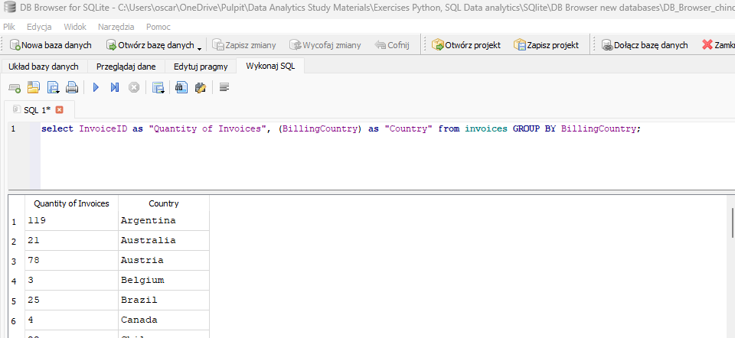
- ✔️ Provide a query that shows the total number of tracks in each playlist. The Playlist name should be included on the resultant table.
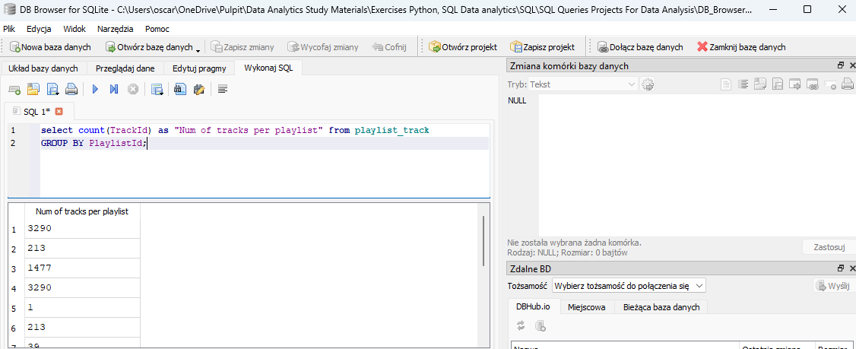
- ✔️ Provide a query that shows all the Tracks, but displays no IDs. The resultant table should include the Album name, Media type and Genre.
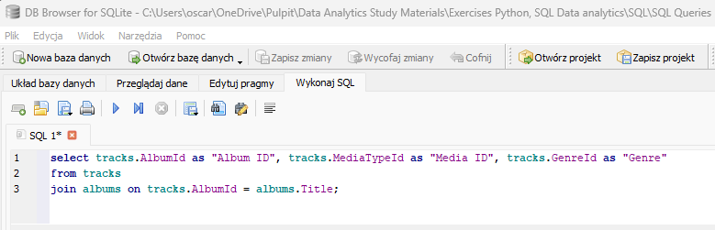
- ✔️ Provide a query that shows all Invoices but includes the # of invoice line items.

- ✔️ Provide a query that shows total sales made by each sales agent.
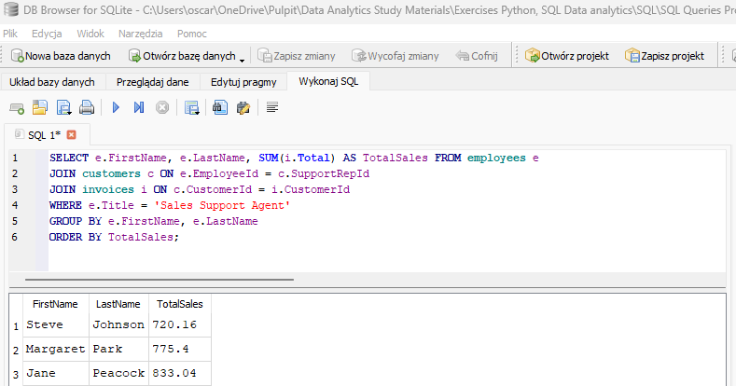
- ✔️ Which sales agent made the most in sales in 2009?
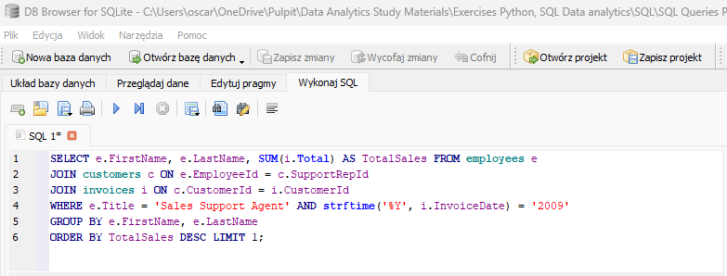
- ✔️ Which sales agent made the most in sales in 2010?
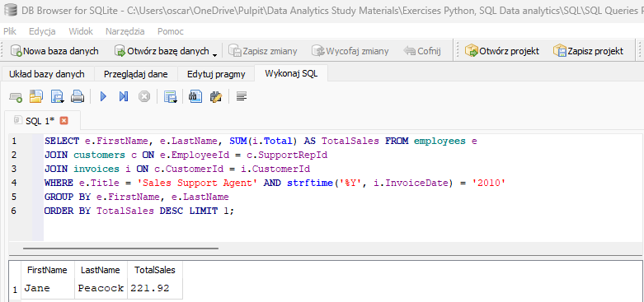
- ✔️ Which sales agent made the most in sales over all?
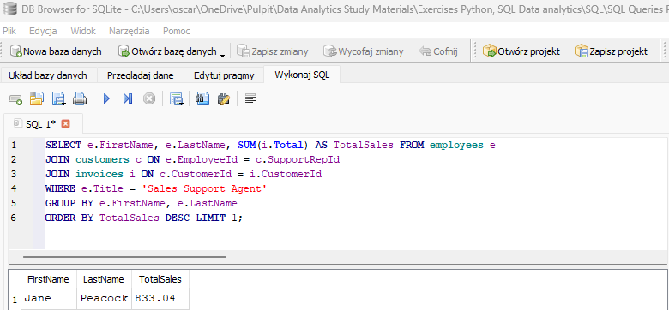
- ✔️ Provide a query that shows the # of customers assigned to each sales agent.
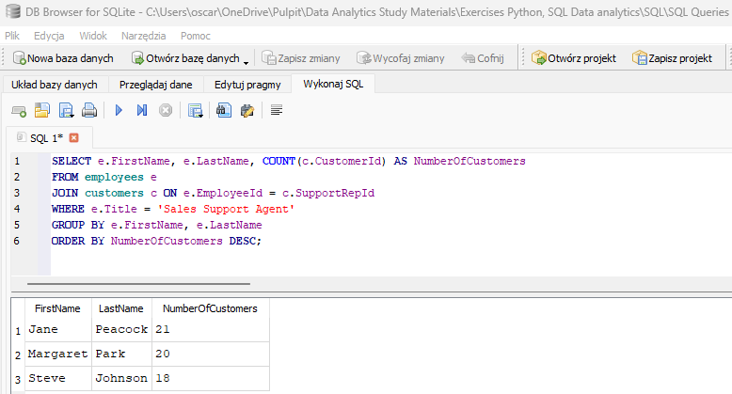
- ✔️ Provide a query that shows the total sales per country. Which country's customers spent the most?
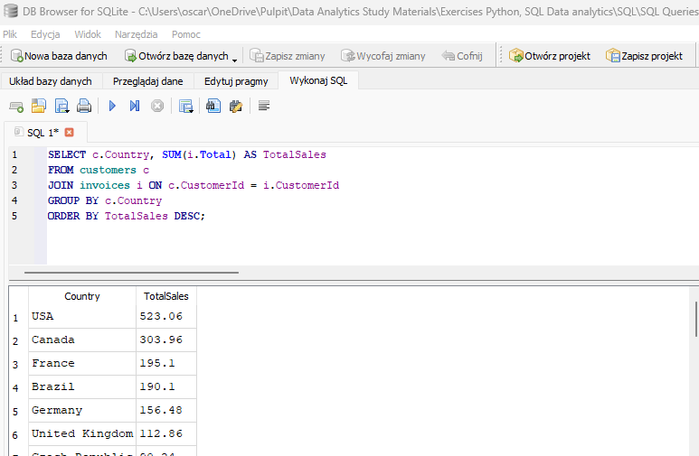
- ✔️ Provide a query that shows the most purchased track of 2013.

- ✔️ Provide a query that shows the top 5 most purchased tracks over all.

- ✔️ Provide a query that shows the top 3 best selling artists.

- ✔️ Provide a query that shows the most purchased Media Type.

- ❓ Provide a query that shows the number tracks purchased in all invoices that contain more than one genre.

